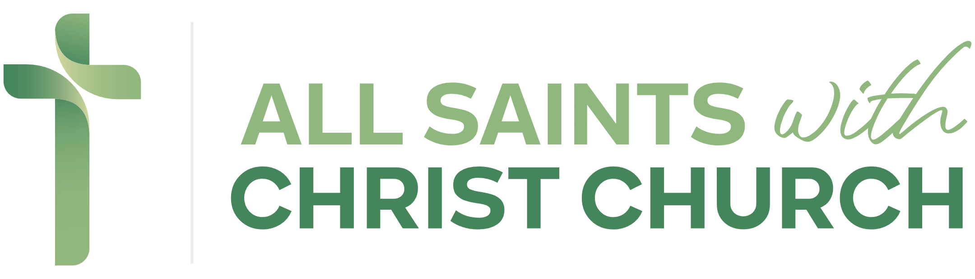
‘A caring church, serving and sharing our faith in Christ’

As a Church we get involved in a wide variety of events and activities, as part of our mission and outreach, at both All Saints Church and Christ Church, alongside Christ Church Community Hall. Any individuals or organisations in our community are welcome to get involved with these where applicable.
These can include events such as our community Christmas Tree Festival, musical performances, Art exhibitions and fundraising projects we may be engaged with, to care for and preserve our churches and community hall.
We would love to keep in touch to update you on any future community events your group or organisation could get involved with or future fundraising projects, where your input may be valuable if you are agreeable. You can opt out of future communication if you decide to, by notifying us via email at Snodlandchurch@gmail.com

Yours sincerely

All Saints with Christ Church Parochial Church Council (PCC)

Future Communication Consent Form

I /We consent to future communication by All Saints with Christ Church as outlined above.

Signed:___________________________ Print Name:_______________________ Date: _________

Name of Organisation/ Group: ___________________________________________

Main Contact Name: __________________________________________

Phone Number: _____________________________________

Email Address: ___________________________________________________

Contact Address: _________________________________________________________

___________________________________________________ Postcode:______________

Privacy and Data Protection – The collection of this data is solely for the uses specified above and will remain confidential, stored in compliance with our GDPR guidelines and not be shared with third parties. For further details please see our Privacy policy at www.allsaintswithchristchurch.org

Please return this form alongside your Christmas Tree application

